Project Design Phase-II
Technology Stack (Architecture & Stack)
Date | 19 July 2026
Team ID
Project Name | Darshan Ease – Temple Darshan Ticket Booking App
Maximum Marks | 4 Marks
Technical Architecture:
The deliverable includes the architectural diagram below along with the information in Table-1 and Table-2.
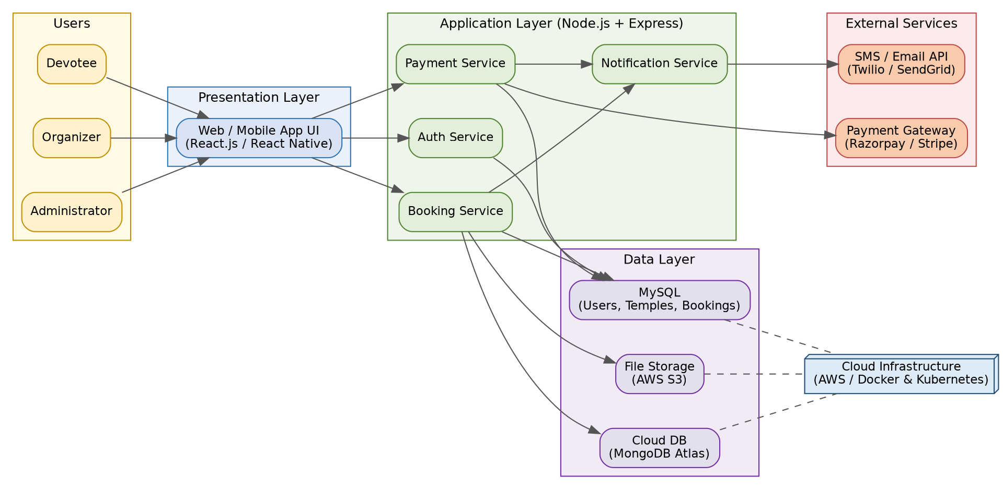
Figure: Darshan Ease — technical architecture diagram
Table-1 : Components & Technologies:
S.No | Component | Description | Technology
1 | User Interface | How devotees, organizers, and admins interact with the application | HTML, CSS, JavaScript, React.js / React Native
2 | Application Logic-1 | Authentication and role-based access control | Node.js, Express.js, JWT
3 | Application Logic-2 | Darshan slot search, booking, and cancellation logic | Node.js, Express.js (MVC architecture)
4 | Application Logic-3 | Payment processing and notification triggers | Node.js, Razorpay/Stripe SDK, Nodemailer
5 | Database | Core relational data: users, temples, bookings | MySQL
6 | Cloud Database | Hosted database service for scalability | MongoDB Atlas / AWS RDS
7 | File Storage | Storage for temple images and payment receipts | AWS S3 / Firebase Storage
8 | External API-1 | Secure online payments and donations | Razorpay API / Stripe API
9 | External API-2 | SMS and email notifications | Twilio API, SendGrid API
10 | Machine Learning Model | (Optional) Predict high-demand slots during festivals | Forecasting model (Python, scikit-learn)
11 | Infrastructure (Server / Cloud) | Application deployment  Local Server Configuration: Node.js + MySQL on localhost  Cloud Server Configuration: AWS EC2 / Docker & Kubernetes | AWS EC2, Docker, Kubernetes
Table-2: Application Characteristics:
S.No | Characteristics | Description | Technology
1 | Open-Source Frameworks | Core open-source frameworks used to build the application | React.js, Node.js, Express.js, MongoDB
2 | Security Implementations | Access controls and protections implemented across the app | JWT auth, HTTPS/TLS, bcrypt hashing, RBAC
3 | Scalable Architecture | 3-tier architecture with services split for booking, payment, and notifications | 3-tier + microservice-style APIs
4 | Availability | Load balancing and distributed servers to keep the platform up during festival traffic spikes | Load balancer, multi-instance deployment
5 | Performance | Caching and CDN use to keep response times low during peak searches and bookings | Redis cache, CDN for static assets
References:
https://c4model.com/
https://www.ibm.com/cloud/architecture
https://aws.amazon.com/architecture

